$ git log

commit d01e461b2094c87ca7fb1f9cba707c056ff6c691

Merge: 8db93c4 e8ad535

Author: egifergiana <egi_fergiana@yahoo.com>

Date: Sat Nov 15 14:01:02 2014 +0700

Merge branch 'master' of https://github.com/egifergiana/tugas-ke-5

commit 8db93c44e0f8b891966d188d1fbf9f26406808f6

Author: egifergiana <egi_fergiana@yahoo.com>

Date: Sat Nov 15 13:59:28 2014 +0700

silahkan lanjutkan jika ada yang kurang

commit e8ad535de3785eadc1c3b1e1989af313541c6d23

Author: egifergiana <egi_fergiana@yahoo>

Date: Sat Nov 15 06:58:34 2014 +0000

Initial commit

acer@ACER-PC /D/kampus/Semester 5/Prak.RPL Lanjut/tugas ke 5 (master)

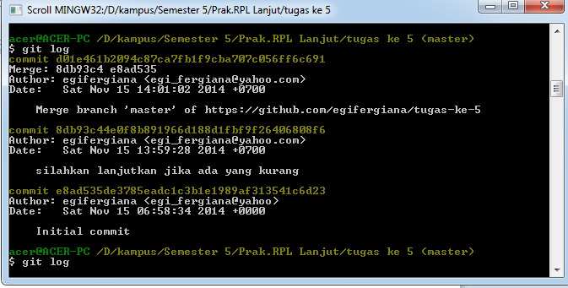

$ git log

commit d01e461b2094c87ca7fb1f9cba707c056ff6c691

Merge: 8db93c4 e8ad535

Author: egifergiana <egi_fergiana@yahoo.com>

Date: Sat Nov 15 14:01:02 2014 +0700

Merge branch 'master' of https://github.com/egifergiana/tugas-ke-5

commit 8db93c44e0f8b891966d188d1fbf9f26406808f6

Author: egifergiana <egi_fergiana@yahoo.com>

Date: Sat Nov 15 13:59:28 2014 +0700

silahkan lanjutkan jika ada yang kurang

commit e8ad535de3785eadc1c3b1e1989af313541c6d23

Author: egifergiana <egi_fergiana@yahoo>

Date: Sat Nov 15 06:58:34 2014 +0000

Initial commit

